
INVITATION
To: From：James Chen 13611187110


The 11th China International Natural Gas Technology & Equipment Exhibition

June 8-10, 2021
New China International Exhibition Center, Beijing

1,800 Exhibitors from 65 Countries and Regions
46 Exhibitors from the Top 500 Enterprises
18 International Pavilions
Nearly 90,000㎡ Exhibit Spaces
120,000 Professional Visitors

Sponsors
Beijing Zhenwei Exhibition Co., Ltd.
Tianjin Zhenwei Exhibition Co., Ltd

Supported by
Zigong clean automobile industry association
Chongqing Changshou Economic & Technological Development Area

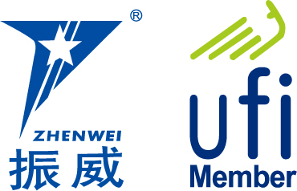

Exhibition Profile
With China’s rapid economic growth, it is of strategic importance to develop its natural gas industry. Statistics released by the International Energy Agency (IEA) show that China will demand 200 billion cubic meters of natural gas in 2016, 300 billion in 2020, and up to 500 billion in 2030. China will rank second only to the United States as one of the largest consumers of natural gas. Issued by the National Energy Administration of China, the 12th Five Year Plan for Natural Gas Development specifies tasks including increasing energy supply, accelerating the construction of pipe networks, LNG terminals, and gas storage facilities, and the strengthening of independent scientific and technological innovations. Driven by these national-level policies and booming demand, China’s natural gas industry will enter into its “Golden Age” of natural gas development.

The 10th China International Natural Gas Technology & Equipment Exhibition (CING) was held concurrently with the 20th China International Petroleum & Petrochemical Technology and Equipment Exhibition (CIPPE). This exhibition welcomed over 2,000 exhibitors from 65 countries and regions, 46 exhibitors from the top 500 enterprises, 18 international pavilions, and 120,000 professional visitors. The exhibition achieved in reaching the capacity of the exhibition floor space of nearly 100,000 square meters.

Some of the 18 national pavilions included the participation of the United States, Germany, Great Britain, France, Canada, Denmark, Italy, Russia, Korea, and the Netherlands. CING has cooperated with the top 10 world companies in the oil and gas industry which include Rosneft Oil, Gazprom, ExxonMobil, BP, Total, Saudi Aramco, Qatar Petroleum, Statoil ASA, Shell, and Schluberger. Top domestic companies in the natural gas industry such as CNPC Kunlun Energy, SINOPEC, CNOOC, SINOCHEM, CHEMCHINA, CSSC, CSIC, CIMC, Xinxing Energy Equipment, Luxi, Endurance, Jereh, JAT-CVA, and SANY have also cooperated with CING, . With all these corporations and relevant organizations collaborating together, the era of natural gas development in China is approaching.

The 10th China International Natural Gas Technology & Equipment Exhibition (CING) attracted thousands of international and domestic media outlets. Among these news media agencies were Xinhua News Agency, People’s Daily, CCTV, China Daily, CHINA PETROLEUM DAILY, CHINA PETROCHEMICAL NEWS, Upstream, World Oils, Oil and Gas Australia, TB Petroleum, China Securities Journal, Shanghai Securities News, CHINA BUSINESS NEWS, The Wall Street Journal, Xinhua net, SINA, and SOHU and People.
With the success of this year's CING exhibition, we warmly welcome you to join us for the 11th CING Exhibition on June 8-10,2021 at Beijing New China International Exhibition Center. We look forward to your participation and attendance.

Concurrent Exhibitions:
The 21st China International Petroleum & Petrochemical Technology and Equipment Exhibition (CIPPE)
The 21st China International Offshore Oil & Gas Exhibition (CIOOE)
The 21st China International Exhibition on Equipment of Pipeline and Oil & Gas Storage and Transportation (CIPE)
The 21st China International Explosion Petroleum Electric Technology & Equipment Exhibition (EXPEC)
The 21st China International Shale Gas Technology and Equipment Exhibition (CISGE)
The 11th China International Offshore Engineering Technology and Equipment Exhibition (CM)

Exhibit Profile
■ Natural gas exploration, exploit, and production equipment
■ Technology and equipment for geophysical exploration, well logging and drilling
■ Gas field land equipment and technology
■ Technology and equipment for LNG engineering
■ Processing technology and equipment for liquefying natural gas
■ Processing technology and equipment for purifying natural gas
■ Technology and equipment for natural gas transportation and storage
■ Natural gas power machinery
■ Equipment of CNG and LNG filling station
■ NGV and LNG ship
■ Accessories of NGV
■ Compressor power equipment
■ Cryogenic temperature heat exchange equipment
■ Cryogenic liquid pump
■ Industrial automation and security system
■ Natural gas power generation technology and equipment
■ Measurement and analysis instrument
■ Fluid separation equipment and valve
■ Special pipelines and materials
■ Other related equipment

Exhibition Schedule
Registration & Setting up：June 6-7, 2021
Exhibition & Trade：June 8-10, 2021
Closing & Dismantling：At 14:00 pm, June 10, 2021
Venue：New China International Exhibition Center, Beijing
Technical Seminar
During the exhibition, we will assist exhibitors in holding seminars, conferences for technical exchanges and new technology & equipment release. Each seminar lasts one hour with CNY 8,000 as the standard expense, and it includes the expenses of event areas and rents of relevant equipment.
Exhibition Rule
- Exhibit space cost: We provide International exhibitors with two participating options.
- Space with Shell Scheme:
Price: standard CNY 30,000 / 9 sqm; Regular size : 3m×3m.
This option includes back & inside walls, carpet, fascia board, one consulting desk, two chairs, two lights and one panel of power points (220V, 5A).
- Raw Space:
Price: CNY 3,200 per sqm (minimum 36 sqm)
There are no exhibition frames and facilities on the raw space. The exhibitors must select the delegated official contractor to customize their stand design. Carpet is not included.
- Additional Exhibitor Service (not required):
Price: CNY 1,200/person (It includes lunches, beverages, opening banquet, gifts, etc)
- Sponsorship Package of cippe
Banquet Sponsor (Exclusive, CNY300, 000)
With around 600 people in the banquet, the participants include VIPs, exhibitors, summit delegates and leaders of visiting and purchasing parties etc. You would get the multiple market promotion paybacks through the banquet.
Gift Sponsor (CNY250, 000)
Distribute to VIP guests. It is the way to show the strength of enterprises and to build strong brands and strengthen its market position.
Exhibition Catalogue Ad.: It will help you to find target consumers. Not only be distributed to professional visitors during the exhibition, but also be distributed through various channels after the exhibition.
Front Cover | CNY 30,000 | Inside Back Cover | CNY 18,000
Back Cover | CNY 25,000 | Head Page | CNY 20,000
Inside Front Cover | CNY 20,000 | Colored Inside Page | CNY 10,000
Size of Catalogue: 130 mm (w) × 210 mm (h)
Show Daily: It will be produced and printed each day during the event, allowing participants to stay up to speed on the latest industry news from the show even around the globe. Whether you want to alert participants to your booth number, build brand awareness, strengthen your company profile, buy or sell goods and services, or recruit professionals, it will significantly help.
Form of Ad. | Publishing Price
Full page | US$8,025 per insertion
Half page | US$5,160 per insertion
US Junior | US$2,628 per insertion
Module 15 | US$1,460 per insertion
Lots of Sponsorship Opportunities are available, such as Visitor Guide Sponsor, Onsite Banner Sponsor, etc. For more information please contact the organizer.
Organizer: Beijing Zhenwei Exhibition Co., Ltd.
Add: Zhenwei Exhibition Building, Building III13, International Enterprise Avenue, Yard 1, Jinghai 5th Road, Tongzhou District, Beijing
Tel: +86-10-50815756 Fax: +86-10-5617 6998
Mob: 13611187110 Http: // www.cingexpo.com.cn
E-mail:ck@zhenweiexpo.com
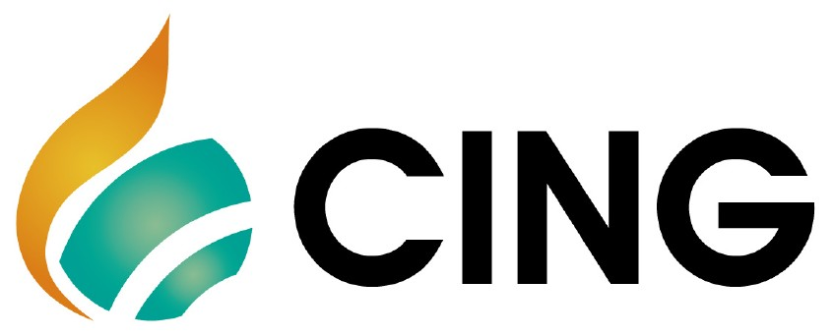
Contact：James Chen

APPLICATION FORM
The 11th China International Natural Gas Technology & Equipment Exhibition
Date: June 8-10, 2021 Venue: New China International Exhibition Center, Beijing

Please fill out the form below and then send it back to the organizer via fax or email.
Company Name:
Address: Country: Postal/Zip code:
Contact Person (Mr. /Ms): Position:
Tel: Fax: Website: E-mail:
Main products/exhibits (English):
Exhibition Mode and Cost
1. Space with shell scheme: sqm (standard CNY30, 000 / 9sqm)
Preferred booth numbers: Fee:
Raw space: sqm (minimum 36 sqm CNY3, 200 / sqm)
Preferred booth numbers: Fee:
2. Advertisement in the Expo Catalogue:
□Front Cover CNY30,000 □Inside Front Cover CNY 20,000 □Head Page CNY20,000 □Back Cover CNY25,000 □Inside Back Cover CNY18,000 □ Colored Inside Page CNY10,000
3. Show Daily: □ Full page US$8,025 per insertion □ Half page US$5,160 per insertion
4. Special Recommended Advertisements:
□ Visitor Ticket CNY50, 000/50,000pieces □ Hanging Banner CNY 50,000/single-side
5. Technical Seminar: Session(s) (CNY8000/session), Fee:
6. Additional Exhibitor Service (CNY1, 200/person, including lunches, beverages, entrance to opening banquet, gifts, etc.): Person(s), Fee:
★Total fee for attendance: Payment Date:
★Special Attention: Please remit the total participation fee to the account appointed by the organizer within 10 working days upon receiving the confirmation letter, and then fax or email the remittance slip/copy to the organizer’s office in time. Booking received without this deposit will not be confirmed.

Beijing Zhenwei Exhibition Co.,Ltd. Applicant:
Tianjin Zhenwei Exhibition Co., Ltd. Tel:
Tel:+86-10-50815756 13611187110 Fax:
Fax: +86-10-5617 6998 E-mail:
E-mail:ck@zhenweiexpo.com Contact:
Contact: James Chen

CING2021 Target Visitors Programme

Exhibitor Name
Website
Company Profile
Products & Technology to be Showcased
What kind of companies you are keenly interested in meeting at CING2021?
Please name some companies you haven’t established business relations but hope to meet at CING2021 (the more the better).
Please name some companies you are already in cooperation with and hope to meet at CING2021 (the more the better).
Note: If the companies you would like to meet are giants like CNPC, SINOPEC, etc. Please name the branch name, departments or main business.

