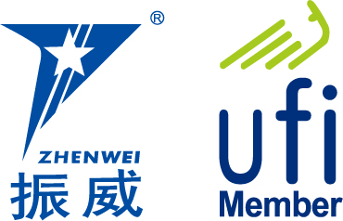
INVITATION

To： From: Zhang Qingxia 13261664569

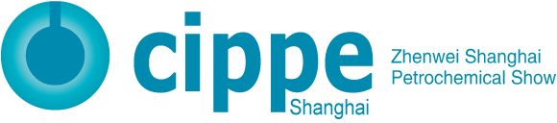

The 14th Shanghai International Petrochemical Technology
and Equipment Exhibition

August 24-26, 2022
Shanghai New International Expo Center, China

The Annual Petrochemical Equipment Event

Sponsors
Beijing Zhenwei Exhibition Co., Ltd.
China Petroleum & Petrochemical Equipment; Industry Association

Organizers
Beijing Zhenwei Exhibition Co., Ltd.

Concurrent:
The 14th Shanghai International Petrochemical Automation & Instruments Exhibition
The 14th Shanghai International Chemical Technology & Equipment Fair
The 14th International Explosion Protection and Electric Technology & Equipment Exhibition
The 14th Shanghai International Petrochemical Safety Production and Protection Products Exhibition
Shanghai International Plastics and Rubbers Exhibition
Shanghai International Medical Chemical Exhibition

Exhibition Profile
cippe is the regular gathering of petroleum and petrochemical industry. There are two sessions in a year, spring in Beijing and autumn in Shanghai.
Shanghai International Petrochemical Technology and Equipment Exhibition (cippe Shanghai Petrochemical Show) has been successfully held for13 years. With an exhibition area exceeds 70,000 square meters, cippe2022 Shanghai is expected to welcome 1,000 exhibitors & 100,000 person-time visitors from 52 countries and regions.
cippe Shanghai Petrochemical Show attracted many well-known international companies such as Schlumberger, GE, Cummins, Caterpillar, Sulzer, NETZSCH, Piller, HERMETIC, Curtiss Wright, IIR, Five Proabd, STEAMLOC, Dellmeco, Yonei, Hakuto, KUMWOO, ASUNG Valve, etc. Well-known domestic enterprises including Shanghai Shenkai, Jereh, Kosun, Aerospace Petrochemical, HISENSE, Wuxi Kipor, BARTEC, Changcheng Pump, Luxi Chemical, Jiangsu Saideli, Jintongling, Liaohe Pharmaceutical Equipment, Hangzhou Feier Filtering, Kaishan Group, Shanghai Senon, Myande, Yixing Grand, Youfumi Group, Zhongteng Environmental Protection, Weidouli Valves, Anhui Shengtang, Jiangsu Xinshijie Pump, Fanqun Drying Equipment, Meluck, etc.
It also welcomed professional visitor delegations from associations and enterprises, such as China Chlor-Alkali Industry Association, China Chemical Enterprise Management Association, Shanghai Chemical Industry Association, Shanghai Chemical Industry (China) Council, Shanghai Coatings and Dyestuff Trade Association, Europump, PPMA, Shell, Exxon Mobil, Total, ConocoPhillips, Equinor, Aramco Asia, SK E&C, Hyundai Engineering, FLUOR, BASF, Sinochem, Yanchang Petroleum, Shengli Oilfield, Shanghai Petrochemical, Sinopec Shanghai Gaoqiao Petrochemical, Sinopec Zhenhai Refining & Chemical, China Oilfield Services, ZRCC, COSL, Wison Engineering, Qilu Petrochemical, CPOE, Shenkai, CNOOC Offshore Oil Engineering, etc.
Welcome to participate in!
Who Should Exhibit
- Petrochemical Plant Device & Equipment
- Petrochemical Process and Technology
- Refinery Technology and Equipment
- Refinery Process Technology
- Petrochemical Products and Advanced Materials
- Automation Technology & Equipment, Instrumentation
- DCS, PLC Control System
- Process Control System and Software
- Fluid Machinery and Process Industry Technology and Equipment
- Sealing Equipment and Accessories
- Power Machinery including Generator Set
- Industrial Explosion-proof Products
- Fire and Alarm Equipment, Articles for Industrial Safety and Labor Protection
- Petrochemical Emergency & Safety Equipment
- Environmental Protection, Safety, Energy-saving Equipment
- Storage, Transportation, Pressure Vessel and Packaging Technology
- Examination & Repair, Maintenance and Management
- Technology and Equipment for Scientific Research and Laboratory
- Communication and Information System
- Electrical & Electronic Equipment, Cable and Wire
- Heat Transfer, Refrigeration, Ventilation Equipment
- Boiler Pressure Vessel Equipment
- Extraction Purification, Evaporation Crystallization
- Separation, Drying, Crushing, Mixing Equipment
- Fuel and Lubrication Technology and Equipment
- Technology and Equipment for Oil and Gas Pipeline Engineering
- Sales System and Facilities (Gas Station Equipment)
- Oil & Gas Recovery Technology and Equipment
- Industrial rinsing and Anti-corrosion
- Auxiliary and Other Equipment
Exhibition Schedule
Registration & Set up: August 22-23, 2022
Exhibition & Trade: August 24-26, 2022
Closure & Dismantling: 14:00pm, August 26, 2022
Venue: Shanghai New International Expo Center (2345 Longyang Road, Pudong New Area, Shanghai, China)
Technical Seminar
The organizer is honored to assist exhibitors in holding technical seminars concurrently with the exhibition. Topics and contents of seminars are up to the discretion of exhibitors. Exhibitors could invite their target customers to participate with no more than 80 attendees. Each seminar lasts one hour with fee of CNY 8,000. The fee covers the space of the seminar and relevant facilities. Please send your topic, content introduction and name of presenter to the organizer before the deadline by July 15th, 2022.
Exhibition Rule
- Booth Cost: This exhibition will provide International exhibitors with two options:
- Standard Booth:
Price: CNY 30,000; Regular size: 3m×3m.
This option includes back & inside walls, carpet, booth fascia board, one consulting desk, two chairs, two fire lights and one power point (220V, 5A).
- Raw space:
Price: CNY 3,200 per sqm (Minimum 36sqm). There are no exhibition frames and facilities on the raw space. The exhibitors must select the delegate official contractor to customize their stand design. Carpet is not included.
- Additional Exhibitor Service (not required):
Price: CNY 1,200/person (Includes 3 lunches, beverages, gala banquet, gifts, etc.)
- Exhibition Catalogue: The exhibition catalogue will be distributed to exhibitors, visitors, and relevant industry colleagues couldn’t attend during the event period. (Size of catalogue: H210mm × W130mm). Prices as follows:
Front Cover | CNY 25,000 | Inside Front Cover | CNY 18,000
Head Page | CNY 18,000 | Back Cover | CNY 20,000
Inside Back Cover | CNY 15,000 | Colored Inside Page | CNY 8,000
- Sponsorship and Promotion Opportunities:
A. For promoting the enterprise's brand awareness and reputation, revealing the outstanding quality of products and services, making enterprises to achieve optimal effect, the organizing committee provides several sponsorship packages and also the flag hanging & banners advertising opportunities for exhibitors.
Note: The organizing committee will email the Exhibitor Manual (including matters of schedule, exhibit transportation, hotel info, booth construction, etc.) to exhibitors two months before the exhibition.


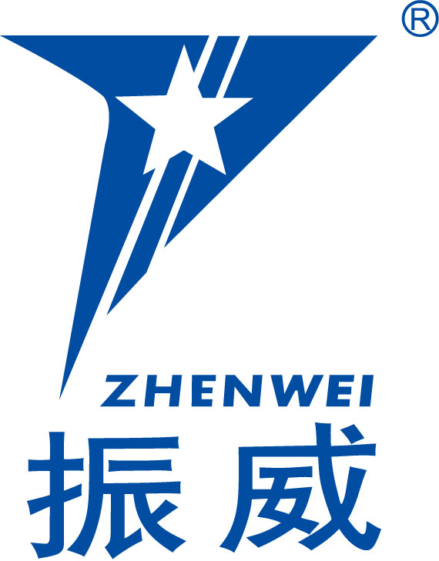
Organizer: Beijing Zhenwei Exhibition Co., Ltd.
Add: Zhenwei Exhibition Building, C13, International Enterprise Avenue III, Yard 1, Jinghai 5th Road, Tongzhou District, 100101, Beijing, China
Tel: 86-10-56176949 Fax: 86-10-5617 6998
http://www.cippe.com.cn E-mail: zqx@zhenweiexpo.com
Contact: Zhang Qingxia 13261664569
cippe Shanghai Application / Contract
The 14th Shanghai International Petrochemical Technology and Equipment Exhibition
Date: August 24-26, 2022 Venue: Shanghai New International Expo Center
Please fill out the form below and send back to the organizer via fax or email. All details will be used for contact and booth headboard purposes.
Company Name:(Chinese)
(English) Address: Postal/Zip code:
Contact Person (Mr. /Ms): Position:
Tel: Fax: Website: E-mail:
Main products/exhibits:
Exhibition Mode and Cost
- Space with Shell Scheme: sqm (standard CNY30,000 / 9sqm)
Preferred booth numbers: Fee:
Raw Space: sqm (CNY3,200/sqm, minimum 36sqm)
Preferred booth numbers: Fee:
- Advertisement in the Expo Catalogue:
□Front Cover CNY25,000 □Inside Front Cover CNY 18,000 □Head Page CNY18,000 □Back Cover CNY20,000 □Inside Back Cover CNY15,000 □Colored Inside Page CNY8,000
Fee:
- Special Recommended Advertisements:
□ Visitor Ticket CNY 50,000/50,000piece □ Handbag (Exclusive) CNY 60,000/20,000pieces
□ Lanyard (Exclusive) CNY60,000/30,000pieces □ Logo in Floor Plan CNY30,000
- Technical Seminar: Session(s) (CNY8,000/session), Fee:
- Additional Exhibitor Service (CNY1,200/person, including lunches, beverages, gala banquet, gifts, etc.):Total: Person(s), Fee:
Total fee for attendance: Payment Date: (DD/MM/YYYY)
★Special Attention: 1. Please remit the total participation fee to the account appointed by the organizer within 10 business days upon receipt the confirmation letter; 2. Booking received without this deposit will not be confirmed; 3. The payment cannot be refunded if the registered exhibitors do not exhibit for its own reason; 4. The exhibiting products should meet the exhibition theme, and should not infringe intellectual property rights, otherwise the exhibitors should bear the full legal responsibility.
Zhenwei Exhibition PLC Applicant:
Beijing Zhenwei Exhibition Co., Ltd. Tel:
Tel: +86-10-5617 6949 Fax:
Fax: +86-10 5617 6998 Email:
Email: zqx@zhenweiexpo.com Contact:
Contact: Zhang Qingxia 13261664569
cippe2022 Shanghai Target Visitors Programme
Exhibitor Name | Chinese
Exhibitor Name | English
Website
Company Profile & Main Products/Technology
Products & Technology to be Showcased
What kind of companies you are keenly interested in meeting
Companies you haven’t established business relations but hope to meet at cippe2022 (the more the better)
Companies you are already in cooperation with and hope to meet at cippe2022 | Company |  | Contact | Tel
Note: If the companies you would like to meet are giants like CNPC, SINOPEC, etc. Please name the branch name, departments or main business.

