INVITATION
To: From:

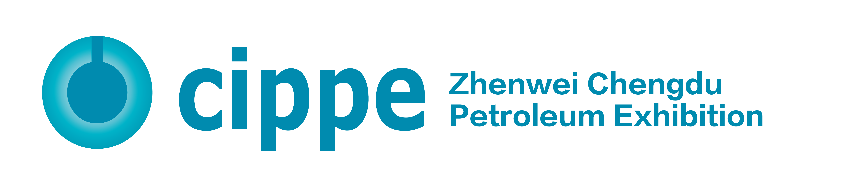

2022 China (Chengdu) International Petroleum & Petrochemical Technology and Equipment Exhibition

Oct. 9-11, 2022
Chengdu Century City New International Convention and Exhibition Center

Organizers
Zhenwei International Exhibition Group
Beijing Zhenwei Exhibition Co., Ltd.

Supporters
China Petroleum and Chemical Industry Federation
China Petroleum & Petrochemical Equipment Industry Association
Explosion-Proof Electrical Apparatus Branch of China Electrical Equipment Industry Association
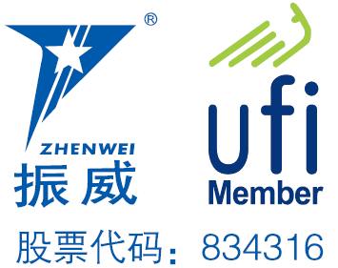

A Grand Industry Event to Create a New Benchmark for Oil & Gas Innovation
China’s Southwest oil and gas resources have always played an important role in national oil & gas industry. On December 2, 2021, the annual output of Shunan gas field reached 10.008 million of oil equivalent. The 14th Five-Year Plan period will witness an accelerated development of China's energy transformation, which will bring more opportunities for certain niches by its green, high-end and differentiated orientations. Guided by the objectives of green, safe, intelligent and innovative, a deep industry reconstruction will be stimulated by consumption upgrades and supply-side structural reforms. As an annual world’s leading event for oil & gas industry, cippe has been committed to supporting enterprises’ growth, and has covered the markets in North China, East China and Southwest China, becoming a one-stop platform serving oil , gas and petrochemical industry.
2022 China (Chengdu) International Petroleum & Petrochemical Technology and Equipment Exhibition (cippe Chengdu) will be held on Oct. 9-11, 2022 at Chengdu Century City New International Convention and Exhibition Center, with an gross exhibition space of 30,000sqm, and is expected to welcome 400+ exhibitors and 20,000+ person-time visitors from home and abroad.
Concurrent Events to Promote In-Depth Exchanges on Cutting-Edge Technologies
Concurrently, 2022 Petroleum & Petrochemical Industry Summit will gather industry associations, research institutes, equipment manufacturers, experts and medias, to collectively discuss hotspots and pain points of the industry, diagnose development trends, integrate resources, technology, information and research achievements, and create a high quality summit of the industry in West China.
Matchmaking Meeting to Effectively Connect Demand and Supply
cippe Business Matchmaking Meeting will be a brand event of cippe Chengdu, aimed to provide a highly-effective, accurate and reliable platform connecting demand and supply. The organizing committee will invite potential purchasers and deliver a VIP service including transportation, accommodation and personalized reception. Based on buyers’ needs, cippe Chengdu will allocate quality exhibitors, and arrange one-on-one communications.
Exhibitions Linkage to Ensure the Quality of Professional Visitors
With more than two decades’ development, the organizer, Zhenwei International Exhibition Group, has been a most specialized exhibition company with rich and profound resources in the industry. Both of its cippe Beijing and cippe Shanghai are leading brand exhibitions. Adhering to the tenet of "Professional Visitors Is The Vitality of Exhibitions", and with the advantageous resources accumulated by the series of cippe events, the organizing committee will focus on key niches and specifically invite core buyers, fully leverage multi-channel promotions by means of telephone, email, SMS, internet, big data marketing, social media, cooperation with industry associations and others, to ensure an effective exhibition.
Quality Medias Support Brand Communications
cippe Chengdu will cooperate with domestic and abroad media partners to promote brand communications, such as Xinhua News, People's Daily, CCTV, China Daily, CNPC Daily, Sinopec Daily, Petroleum Business News, Upstream, Worldoils, Digital Refining, Oil & Gas Product News, Gulf Oilfield Directory, China Securities Journal, Shanghai Securities News, China Business News, Wall Street Journal, XINHUANET, Sina, Sohu, PeopleNet, etc.
Exhibition Schedule
Registration & Setting up: Oct. 7 - 8, 2022
Exhibition Opening: Oct. 9 - 11, 2022
Closing & Dismantling: Begin at 14:00pm, Oct. 11, 2022
Exhibit Profile
• Oil & gas exploration, exploit, and production equipment
• Geophysical exploration, well logging and drilling technology and equipment
• Well completion technology and equipment
• Marine engineering technology and equipment
• Natural gas technology and equipment
• Automation technology equipment, instruments and meters
• Oil and gas field surface engineering technology and equipment
• Petroleum & petrochemical equipment and manufacturing
• Industrial explosion-proof products
• Oil and gas pipeline engineering
• Underground engineering and trenchless technology and equipment
• Power systems, power generation and supply
• Oil and Gas Storage & Transportation
• Oilfield Special Vehicle
• Electrical & electronic equipment, cable and electric wire
• Oil refining technological process and equipment
• Petrochemical process and technology
• Examination & repair, maintenance, and management
• Fluid control equipment- Compressor, Pump, Blower and Valve
• Pressure Vessels
• Oil and lubricating oil technology and equipment
• Petrochemical products and advanced material
• Refueling station equipment
• Environmental protection and energy conservation
• Fire and alarm equipment, articles for industrial safety and labor protection
• Anti-corrosion technology and material, industrial rinsing
• Packing, sealing, gasket, fastener, bearing
• Digital solutions for oil and gas industry
• Communications and information technology
• Hydrogen technology and equipment
• Certification, consulting services
• Scientific research and laboratory in petroleum & petrochemical industry
• Tools & Spare Parts
Exhibiting Costs (Not Including VAT)
Exhibition Space | Shell Scheme Booth:  Price: CNY 21,800/9SQM; Regular Size : 3m×3m.  This option includes back & inside walls, carpet, lintel board, one consulting table, two chairs, two lights and one power socket (220V, 5A).  Please specify in advance for special electricity use, and will be charged separately.
Raw Space:
Price: CNY 2,180/SQM (Minimum 36sqm).
Empty exhibition space for exhibitor to customize booth design and construction. The exhibitors shall not choose a contractor that is not designated by the organizer.
Exhibitor Service | Additional Exhibitor Service  Price: CNY 1,200/person (Includes lunches, beverages, manuals, gifts, etc.)
Catalogue Ad. | Front Cover: CNY 25,000 Inside Back Cover: CNY 15,000  Back Cover: CNY 20,000 Head Page: CNY 18,000  Inside Front Cover: CNY 15,000 Colored Inside Page: CNY 8,000  Size: 130mm (width) × 210mm (height)
Technical Seminar | A series of technical seminars will be held during the exhibition so as to maximally meet participants’ requirements for technical communication and products launch as well.  Technical Seminar (Conference Room)  Price: CNY15,000/Session  Including venue, audio equipment, projector, on-site sign, water, etc.
More Sponsorship Opportunities, please contact cippe Chengdu organizational committee.
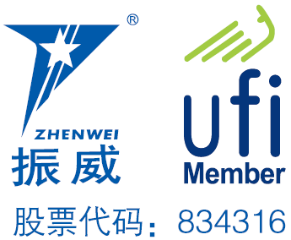
Organizer: Zhenwei International Exhibition Group Beijing Zhenwei Exhibition Co., Ltd.
Add: Zhenwei Exhibition Building, Building III13, International Enterprise Avenue, Yard 1, Jinghai 5th Road, Tongzhou District, Beijing
Tel: 010-56176967 Fax: 010-5617 6998
www.cd.cippe.com.cn E-mail: tongliying@zhenweiexpo.com Contact: Kathie Tong

Application Form
2022 China (Chengdu) International Petroleum & Petrochemical Technology and Equipment Exhibition
Oct. 9 - 11, 2022 Chengdu Century City New International Convention and Exhibition Center
Please fill out the form below and then send it back to the organizer via fax or email.
Company Name:
Address: Country: Postal/Zip code:
Contact (Mr. / Ms.): Position:
Mobile: TEL: FAX:
Website: E-mail:
Main products/exhibits (English):
Exhibition Space
□ Shell Scheme: SQM (CNY21, 800 / 9sqm)
Preferred booth numbers: Fee:
- Raw space: SQM (CNY2, 180/sqm minimum 36sqm)
Preferred booth numbers: Fee:
Sponsorship & Advertisement
- Exhibition Catalogue Ad.
□ Front Cover CNY25,000 □ Inside Front Cover CNY15,000 □ Head Page CNY18,000
□ Back Cover CNY20,000 □ Inside Back Cover CNY15,000 □ Colored Inside Page CNY8,000
- Technical Seminar
□ Technical Seminar CNY15,000/Session
□ Additional Exhibitor Service CNY 1,200/person Person(s)
Total fee: Payment Date:
Special Attentions:
- Please remit the total participation fee to the account appointed by the organizer within 7 business days upon receipt the confirmation letter; 2. Booking received without this deposit will not be confirmed; 3. The payment cannot be refunded if exhibitors do not exhibit for its own reason; 4. The exhibiting products should meet the exhibit scope and theme, and should not infringe intellectual property rights, otherwise the exhibitors should bear the full legal responsibility; 5. Exhibitors shall not choose a contractor that is not designated by the organizer.
Beijing Zhenwei Exhibition Co., Ltd.  Tel: +86-010-56176967  Mobile: +86 -13521063550  Email: 491699850@qq.com  Contact: Kathie Tong | Company Name:  Signature & Stamp:

