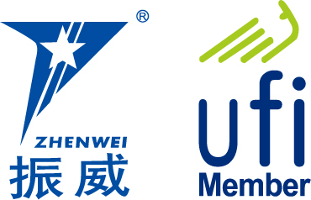
INVITATION

To： From: Blake



The 11th Shanghai International Petrochemical
Technology and Equipment Exhibition

August 28-30, 2019
Shanghai New International Expo Center, China

Focus on Technology and Equipment of Downstream and Midstream in Petroleum Industry

Sponsors
Tianjin Zhenwei Exhibition Co., Ltd.
Beijing Zhenwei Exhibition Co., Ltd.
CCPIT Sub-council of Chemical Industry
Petroleum & Equipment
Organizers
Tianjin Zhenwei Exhibition Co., Ltd.
Beijing Zhenwei Exhibition Co., Ltd.

Concurrent: The 11th Shanghai International General Fluid Technology Equipment Exhibition
The 11th Shanghai International Solid WasteTreament and Equipment Exhibition
The 11th Shanghai lnternational Petrochemical Fire-Protection Equipment and Safety Protection
Products Exhibtion
The 11th Shanghai International Fastener and Equipment Exhibition

Exhibition Profile
cippe has become the regular gathering of petroleum and petrochemical industry. There are two sessions in one year, held in spring in Beijing and autumn in Shanghai every year.
Shanghai has been held successfully for10 years. cippe 2018 Shanghai attracts 600 enterprises from 52 countries and regions including USA, Germany, Italy, Russia, Germany，France, Japan, Singapore etc. The exhibition area exceeds 38,000 Square meters.
The exhibition attracted many leading international companies such as SCHLUMBERGER, GE, CUMMINS, caterpillar, AFRISO, testo, CONEWELL, rieckermann, DIXON, safoco, MARTIN, etc.
The well-known domestic enterprises including SHANGHAI SHENKAI，SUCHUAN HONGHUA, ZPMC, CIMC RAFFLES, JERELL, SOLIDS CONTROL, KOSUN, SHENYANG BLONNER, WUXI Compressor, bartec, HISENSE, cnr, SMARTER GROUP, etc.
cippe Shanghai attracts both domestic and overseas buyer groups, including Shell, Exxon Mobil, Total, ConocoPhillips, Statoil, Petrobras, Yanchang Group, SHENGLI Oilfield, ZHEJIANG Oilfield, Shanghai Petrochemical, Takahashi petrochemical, ZRCC, GWDC, Bohai Drilling, COSL, Wison Engineering, Qilu Petrochemical, CPOE , Shanghai Offshore Oil Bureau, etc.
China Offshore Engineering Summit will take place along the exhibition. Welcome to visiting and participating!

Who Should Exhibit
■ Petroleum & petrochemical equipment and manufacturing
■ Technology and equipment for oil and gas pipeline engineering
■ Technology and equipment for geophysical exploration, well logging and drilling ( for onshore and offshore ).
■ Examination & repair, maintenance, and management of petroleum & petrochemical equipments
■ Technology and equipment for scientific research and laboratory in petroleum & petrochemical industry
■ Oil & gas exploration, exploit, and production equipment
■ Driving machinery including generation set
■ Technological process and equipment for oil refining.
■ Pcl & Dcs control system, on-site bus technical equipment
■ Industrial automation plant and instrumentation
■ Oil & gas ground technical equipment
■ Technologies and equipment for safety, environmental protection, and energy conservation
■ Petrochemical production and advanced material
■ Electrical & electronic equipment, cable and electric wire
■ Sales system and facilities in petrol & gas station
■ Pipeline, tank car and special vehicles for oil and gas transportation
■ Fluid control equipment- Compressor, Pump, Blower and Valve
■ Fire and alarm equipment, articles for industrial safety and labor protection
■ Industrial explosion-proof products
■ Equipment for industrial rinsing, technology and material for anti-corrosion.
■ Communication, management information system, and e-commerce
■ Technology and equipment for loading & unloading, packaging, storing & transporting

Technical Seminar
The organizer is honored to assist exhibitors in holding technical seminars for information purposes. The topic and content of each technical seminar is up to the discretion of the exhibitor. The company may invite your target customers to participate with no more than 80 attendees. Each seminar lasts one hour with fee of CNY 8,000. The fee covers the space of the seminar and relevant facility. Please send your topic, content introduction and name of presenter to the organizer before the deadline by July 22nd, 2019

Exhibition Schedule
Registration & Set up：August 26-27, 2019
Exhibition & Trade： August 28-30, 2019
Closure & Dismantling: 14:00pm, August 30, 2019
Venue：Shanghai New International Expo Center, China (2345 Longyang Road, Pudong New Area, Shanghai)

Exhibition Rule
- Booth Cost: This exhibition will provide International exhibitors with two options:
- Standard Booth:
Price: Standard 9 sqm CNY 30,000; Regular size : 3m×3m.
This option includes back & inside walls, carpet, booth fascia board, one consulting desk, two chairs, two fire lights and one power point (220V, 5A).
- Raw space:
Price: CNY 3,200 per sqm (Minimum rent space: 36 sqm). There are no exhibition frames and facilities on the raw space. The exhibitors must select the delegate official contractor to customize their stand design. Carpet is not included.
- Additional Exhibitor Service (not required):
Price: CNY 1,200/person (Includes 3 lunches, beverages, gala banquet, gifts, etc.

3. Exhibition Catalogue: a guide to help you find your target customer after the exhibition! The exhibition catalogue will be distributed to relevant businesses besides visitors from around the world during the exhibition period.
Prices for catalogue advertisement are listed below:
Front Cover | CNY 25,000 | Inside Front Cover | CNY 18,000
Head Page | CNY 18,000 | Back Cover | CNY 20,000
Inside Back Cover | CNY 15,000 | Colored Inside Page | CNY 8,000
Notice: size of catalogue: 210mm（H）×130mm（W）

4．Sponsorship and Promotion Opportunities:
A. For promoting the enterprise's brand awareness and reputation, revealing the outstanding quality of products and services, making enterprises to achieve optimal effect, the organizing committee provides several sponsorship packages and also the flag hanging & banners advertising opportunities for exhibitors.
B. Show Daily for three days with both Chinese and English edition will be published during the exhibition with 20,000 copies every day to all the visitors and exhibitors for free. It will be a good platform for exhibitors to advertise your exhibiting products and build your brand awareness.

Organizer: Beijing Zhenwei Exhibition Co., Ltd.
Add: 801, Building E, Kaixuancheng, 170, Beiyuan Road,

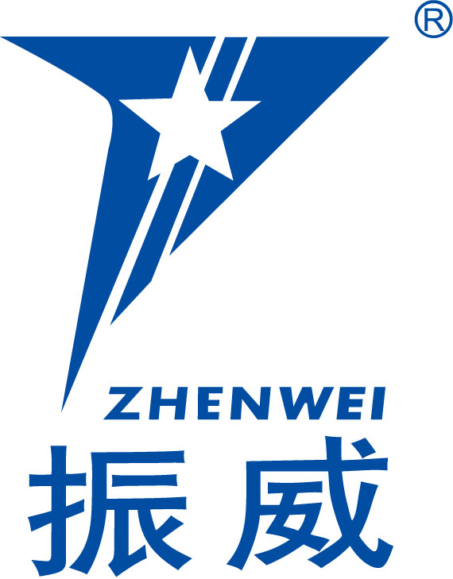
Chaoyang District, Beijing 100101, China
Tel: 010-58236551 Fax: +86-10-5823 6567
http://www.cippe.com.cn E-mail: gl@zhenweiexpo.com
Contact: Blake

cippe Shanghai Application / Contract
The 11th Shanghai International Petrochemical Technology and Equipment Exhibition
Date: August 28-30, 2019
Venue: Shanghai New International Expo Center, China (2345 Longyang Road, Pudong New Area, Shanghai)
Please fill out the form below and send it back to the organizer via fax or email. All details will be used for contact and booth headboard purposes.
Company Name:(Chinese)
(English) Address: Postal/Zip code:
Contact Person (Mr. /Ms): Position:
Tel: Fax: Website: E-mail:
Main products/exhibits:
Exhibition Mode and Cost
- Space with shell scheme: sqm (standard CNY30,000 / 9sqm)
Preferred booth numbers: Fee:
Raw space: sqm (minimum 36 sqm CNY3,200 / sqm)
Preferred booth numbers: Fee:
- Advertisement in the Expo Catalogue:
□Front Cover CNY25,000 □Inside Front Cover CNY 18,000 □Head Page CNY18,000 □Back Cover CNY20,000 □Inside Back Cover CNY15,000 □ Colored Inside Page CNY8,000 Fee:
- Special Recommended Advertisements:
□ Visitor Ticket CNY 50,000/50,000piece □ Handbag CNY 60,000/20,000pieces
□ Lanyard (Exclusive) CNY60,000/30,000pieces □ Logo in Floor Plan CNY30,000
Platinum member: CNY3680 /year.
- Technical Seminar: Session(s) (CNY8000/session), Fee:
- Additional Exhibitor Service (CNY1200/person, including lunches, beverages, gala banquet, gifts, etc.):Total: Person(s), Fee:
Total fee for attendance: Payment Date: Day Month Year

★Special Attention: 1. Please remit the total participation fee to the account appointed by the organizer within 10 business days upon receipt the confirmation letter; 2. Booking received without this deposit will not be confirmed; 3. The payment cannot be refunded if the registered exhibitors do not exhibit for its own reason; 4. The exhibiting products should meet the exhibit scope and theme, and should not infringe intellectual property rights, otherwise the exhibitors should bear the full legal responsibility.

Beijing Zhenwei Exhibition Co.,Ltd. Applicant:
Tianjin Zhenwei Exhibition Co., Ltd. Tel:
Tel: +86-10-5823 6551 Fax:
Fax: +86-10 5823 6567 E-mail:
E-mail:gl@zhenweiexpo.com Contact:
Contact: Blake

