
INVITATION
To: From：James Chen 13611187110


The 12th Beijing International Natural Gas Technology & Equipment Exhibition

March 21-23, 2022
New China International Exhibition Center, Beijing

1,800 Exhibitors from 65 Countries and Regions
46 Exhibitors from Fortune Global 500
18 National Pavilions
90,000m² Exhibition Space
123,000 Professional Visitors

Sponsors
Zhenwei International Exhibition Group
Beijing Zhenwei Exhibition Co., Ltd.

Supported by
Zigong clean automobile industry association
Chongqing Changshou Economic & Technological Development Area

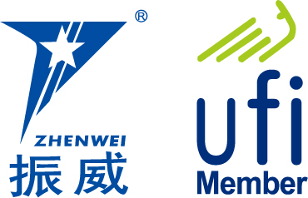

Exhibition Profile
With China’s rapid economic growth, it is of strategic importance to develop its natural gas industry. Statistics released by the International Energy Agency (IEA) show that China will demand 200 billion cubic meters of natural gas in 2016, 300 billion in 2020, and up to 500 billion in 2030. China will rank second only to the United States as one of the largest consumers of natural gas. Issued by the National Energy Administration of China, the 12th Five Yea-r Plan for Natural Gas Development specifies tasks including increasing energy supply, accelerating the construction of pipe networks, LNG terminals, and gas storage facilities, and the strengthening of independent scientific and technological innovations. Driven by these national-level policies and booming demand, China’s natural gas industry will enter into its “Golden Age” of natural gas development.

The 11th China International Natural Gas Technology & Equipment Exhibition (CING) was held concurrently with the 21st China International Petroleum & Petrochemical Technology and Equipment Exhibition (CIPPE). This exhibition welcomed over 1,800 exhibitors from 65 countries and regions, 46 exhibitors from the top 500 enterprises, 18 international pavilions, and 123,000 professional visitors. The exhibition achieved in reaching the capacity of the exhibition floor space of nearly 90,000 square meters.

Some of the 18 national pavilions included the participation of the United States, Germany, Great Britain, France, Canada, Denmark, Italy, Russia, Korea, and the Netherlands. CING has cooperated with the top 10 world companies in the oil and gas industry which include Rosneft Oil, Gazprom, ExxonMobil, BP, Total, Saudi Aramco, Qatar Petroleum, Statoil ASA, Shell, and Schluberger. Top domestic companies in the natural gas industry such as CNPC Kunlun Energy, SINOPEC, CNOOC, SINOCHEM, CHEMCHINA, CSSC, CSIC, CIMC, Xinxing Energy Equipment, Luxi, Endurance, Jereh, WEICHAI,Taihe petrochemical,JAT-CVA, and SANY have also cooperated with CING, . With all these corporations and relevant organizations collaborating together, the era of natural gas development in China is approaching.

The 11th China International Natural Gas Technology & Equipment Exhibition (CING) attracted thousands of international and domestic media outlets. Among these news media agencies were Xinhua News Agency, People’s Daily, CCTV, China Daily, CHINA PETROLEUM DAILY, CHINA PETROCHEMICAL NEWS, Upstream, World Oils, Oil and Gas Australia, TB Petroleum, China Securities Journal, Shanghai Securities News, CHINA BUSINESS NEWS, The Wall Street Journal, Xinhua net, SINA, and SOHU and People.
With the success of this year's CING exhibition, we warmly welcome you to join us for the 12th CING Exhibition on March 21-23,2022 at Beijing New China International Exhibition Center. We look forward to your participation and attendance.

Concurrent Exhibitions:
The 22nd China International Petroleum & Petrochemical Technology and Equipment Exhibition (cippe)
The 22nd Beijing International Exhibition on Equipment of Pipeline and Oil & Gas Storage and Transportation(CIPE)
The 22nd Beijing International Offshore Oil & Gas Exhibition(ciooe)
The 22nd Beijing International Explosion Proof Electric Technology & Equipment Exhibition（Expec）
The 12th Beijing International Shale Gas Technology and Equipment Exhibition(cisge)
The 12th Beijing International Offshore Engineering Technology & Equipment Exhibition(CM)
Beijing International Petroleum & Chemical Automation Technology & Equipment and Instrumentation Exhibition(cieca)
Beijing International petroleum and Petrochemical Safety Production Exhibition(cipse)
2022 Beijing International hydrogen Technology & Equipment Exhibition（HEIE）
2022 Beijing International Gas Applications and Technical Equipment Exhibition (GAS)
2022 Beijing International Underground Engineering Construction and Trenchless Technology and Equipment Exhibition (CITTE)

Exhibit Profile
■ Natural gas exploration, exploit, and production equipment
■ Technology and equipment for geophysical exploration, well logging and drilling
■ Gas field land equipment and technology
■ Technology and equipment for LNG engineering
■ Processing technology and equipment for liquefying natural gas
■ Processing technology and equipment for purifying natural gas
■ Technology and equipment for natural gas transportation and storage
■ Natural gas power machinery
■ Equipment of CNG and LNG filling station
■ NGV and LNG ship
■ Accessories of NGV
■ Compressor power equipment
■ Cryogenic temperature heat exchange equipment
■ Cryogenic liquid pump
■ Industrial automation and security system
■ Natural gas power generation technology and equipment
■ Measurement and analysis instrument
■ Fluid separation equipment and valve
■ Special pipelines and materials
■ Other related equipment

Exhibiting Costs
Exhibition Space | Shell Scheme:  Price: CNY 30,000/9SQM; Regular size : 3m×3m.  This option includes back & inside walls, carpet, lintel board, one consulting table, two chairs, two lights and one power socket (220V, 5A).
Exhibition Space | Raw Space:  Price: CNY 3,200/SQM. (Mini.36sqm).  Empty exhibition space for exhibitor to customize booth design and construction. The exhibitors shall not choose a contractor that which is not appointed to design and or construct their special design.
Exhibitor Service | Additional Exhibitor Service  Price: CNY 1,200/person (It includes lunches, beverages, opening banquet, gifts, etc.)
Exhibition Catalogue Ad. | Front Cover: CNY 36,000 Inside Back Cover: CNY 22,000  Back Cover: CNY 30,000 Head Page: CNY 25,000  Inside Front Cover: CNY 25,000 Colored Inside Page: CNY 12,000
Technical Seminar | A series of technical seminars will be held during the exhibition so as to maximally meet participants’ requirements for technical communication and products launch as well.  Technical Seminar (Conference Room)  Price: CNY8,000/Session  New Product/Technology Promotion Session (Exhibition Hall Seminar Area)  Price: CNY15,000/30minutes
Exclusive Sponsor | Banquet Sponsor: CNY360,000  With around 600 participants, including VIPs, exhibitors, summit delegates, industrial leaders and professional purchasers, etc., the Banquet will offer you with an excellent opportunity for market campaign.  Gift Sponsor: CNY300,000  All the sponsored gifts will be distributed to VIP guests. It is an efficient way to show the strength of the sponsor, to promote brand awareness and to enhance market position as well.  Visitor Guide Sponsor: CNY960,000(Back cover advertisement)
Media Promotion | Pre-show Promotion: CNY 2,000/time  Post-show Promotion: CNY 2,000/time  During the show promotion: CNY 7,000/time
Photography Service | Photography and video  Price: CNY4,000/day
Live Broadcasting | Exhibition visiting live broadcasting  Price: CNY2,000/session (5-20minutes)
Live Broadcasting | Customized exhibition live broadcasting  Price: CNY50,000/day

More Sponsorship Opportunities are available as well. For more information please contact with the cippe organizational committee.

Organizer: Zhenwei International Exhibition Group
Beijing Zhenwei Exhibition Co., Ltd.
Add: Zhenwei Exhibition Building, Building III13, International Enterprise Avenue, Yard 1, Jinghai 5th Road, Tongzhou District, Beijing
Tel: +86-10-50815756 Fax: +86-10-5617 6998
Mob: 13611187110 Http: // www.cingexpo.com.cn
E-mail: ck@zhenweiexpo.com
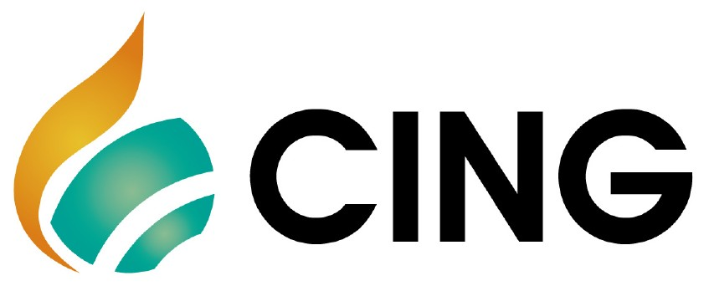
Contact：James Chen

Application Form
The 12th Beijing International Natural Gas Technology & Equipment Exhibition
Date: March 21-23, 2022 Venue: New China International Exhibition Center, Beijing
Please fill out the form below and then send it back to the organizer via fax or email.
Company Name:
Address: Country: Postal/Zip code:
Contact (Mr. / Ms.): Position:
Mobile: TEL: FAX:
Website: E-mail:
Main products/exhibits (English):
Exhibition Space
□ Shell scheme: SQM (CNY30, 000 / 9sqm)
Preferred booth numbers: Fee:
- Raw space: SQM (CNY3, 200 / SQM minimum 36 SQM)
Preferred booth numbers: Fee:
Sponsorship & Advertisement
- Exhibition Catalogue Ad.
□Front Cover CNY36,000 □Inside Front Cover CNY25,000 □Head Page CNY25,000 □Back Cover CNY30,000 □Inside Back Cover CNY22,000 □Colored Inside Page CNY12,000
- Technical Seminar
□Technical Seminar CNY8,000/Session
□New Product/Technology Promotion Session CNY15,000/30minutes
- Exclusive Sponsor
□Banquet Sponsor: CNY360,000 □Gift Sponsor: CNY300,000
□Visitor Guide Sponsor: CNY960,000
□ Media Promotion
□Pre-show Promotion: CNY 2,000/time □Post-show Promotion: CNY 2,000/time
□During the show promotion: CNY 7,000/time
□ Photography Service
□Photography and video CNY4,000/day
□ Live Broadcasting
□Exhibition visiting live broadcasting CNY2,000/session
□Customized exhibition live broadcasting CNY50,000/day
□ Additional Exhibitor Service CNY 1,200/person Person(s)
Total fee: Payment Date:
Special Attention:
1.Please remit the total participation fee to the account appointed by the organizer within 10 business days upon receipt the confirmation letter; 2. Booking received without this deposit will not be confirmed; 3.The payment cannot be refunded if the registered exhibitors do not exhibit for its own reason; 4.The exhibiting products should meet the exhibit scope and theme, and should not infringe 5.intellectual property rights, otherwise the exhibitors should bear the full legal responsibility.
Beijing Zhenwei Exhibition Co., Ltd.  Tel:+86-10-50815756  Fax: +86-10-5617 6998  E-mail: ck@zhenweiexpo.com  Contact: James Chen | Company Name:  Signature & Stamp:

CING2022 Target Visitors Programme

Exhibitor Name
Website
Company Profile
Products & Technology to be Showcased
What kind of companies you are keenly interested in meeting at CING2022?
Please name some companies you haven’t established business relations but hope to meet at CING2022 (the more the better).
Please name some companies you are already in cooperation with and hope to meet at CING2022(the more the better).
Note: If the companies you would like to meet are giants like CNPC, SINOPEC, etc. Please name the branch name, departments or main business.

