Times International Conference & Exhibition Co., Ltd. has been appointed as the only official accommodation reservation agent. To ensure the good accommodation for the exhibitors and visitors during CIPPE 2020 from 03/July.- 05/July, while saving the cost, we have reserved rooms in the nearest hotels around the CIEC(NEW) with discounted rates as follows.
The 20th China International Petroleum & Petrochemical Technology and Equipment Exhibition
Submission Deadline: 15th,Jun.
Code | Hotel Name | Preferential Rate | Room Type | Internet | Distance to New CIEC
1 | Crowne Plaza Beijing International Airport  ★★★★★ | ￥930/N | Superior Room | Free | 0.5km  (10min on foot)
1 | Crowne Plaza Beijing International Airport  ★★★★★ | ￥1030/N | Deluxe Room | Free | 0.5km  (10min on foot)
2 | Ramada by Wyndham Beijing Airport  ★★★★ | ￥600/N | Superior Room | Free | 3.0km  (free shuttle bus)
3 | Beijing WanSi Hotel  ★★★★ | ￥560/N | Standard Room | Free | 2.0km  (free shuttle bus)i
4 | CITIC Hotel Beijing Airport  ★★★★ | ￥490/N | Standard Room | Free | 4.0km  (free shuttle bus)

Hotel Name | Address | Outlook | Lobby | Room
Crowne Plaza Beijing International Airport  ★★★★★ | No.60 Fuqian 1st Street, Beijing, China | 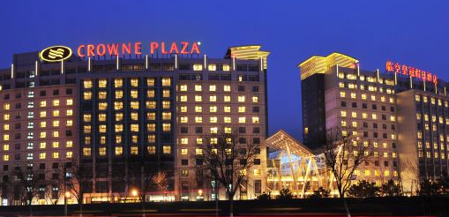 | 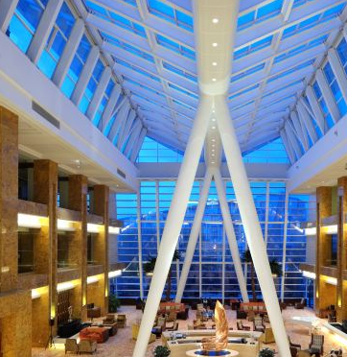 | 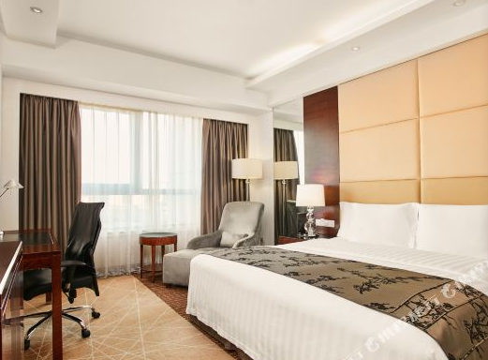
Ramada by Wyndham Beijing Airport  ★★★★ | No.13 Fuqian 1st Street, Tianzhu Town, Beijing, China | 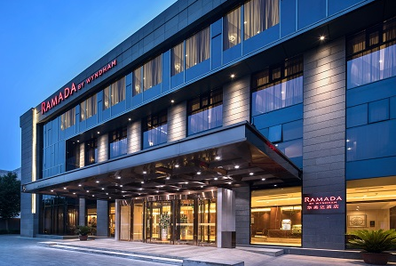 | 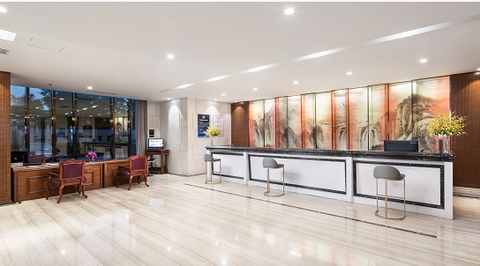 | 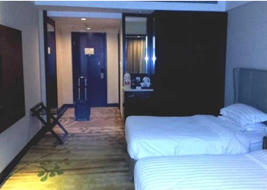
Beijing WanSi Hotel ★★★★ | No.30 Fuqian 1st Street, Tianzhu Town, Beijing, China | 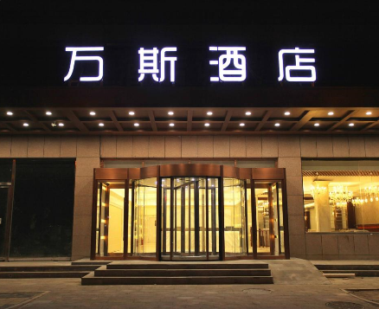 | 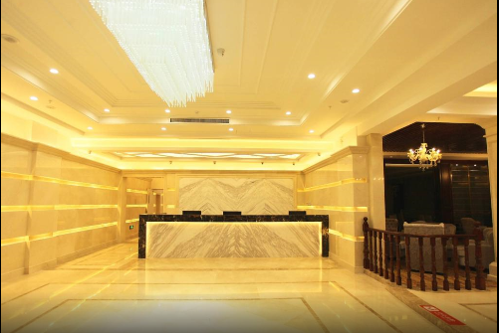 | 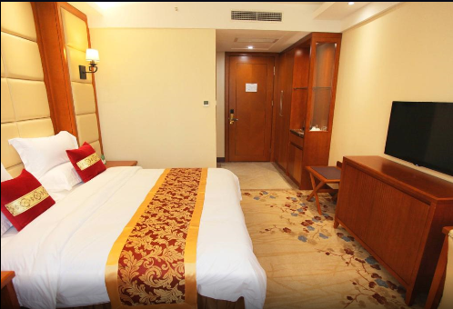
CITIC Hotel Beijing Airport  ★★★★ | No. 9 Xiao Tianzhu Road, Capital International Airport, Beijing | 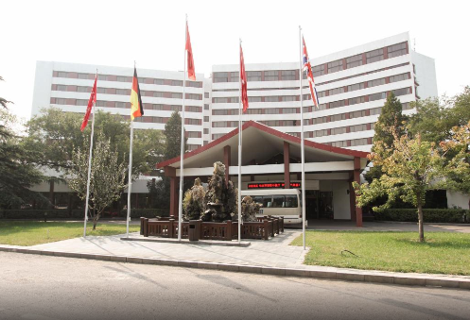 | 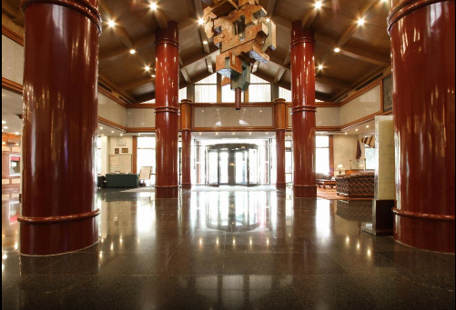 | 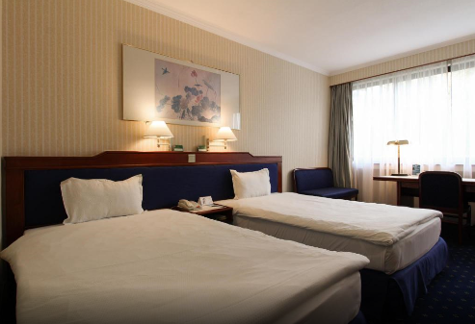
Hotel Reservation Form

Company Name Booth No.____________________________
Contact__________________________________ Mobile_________________________ Position
Email Tel_______________________________ Fax_________________________________
Hotel Name  (Code) | Full name (Same as on Passport) | Check-in Date | Check-out Date | Room Type  (King-size or Twin bed) | Remark
 | □Mr. □Ms.
 | □Mr. □Ms.
 | □Mr. □Ms.
 | □Mr. □Ms.
 | □Mr. □Ms.
If you need other services as follows, please mark at the form and email us in details.
Code | Item | Y/N
1 | Staff Service | YES □ NO □
2 | Car Rental Service | YES □ NO □
3 | Conference Service | YES □ NO □
4 | Travel Service | YES □ NO □
Notes：
- As hotel requested, all your cost will be paid in advance by T/T or PayPal once you book.
- Any changes or cancellations are not allowed, your payment will fully guarantee all your rooms and nights.
- If you need other services such as car rental,conference, tourism, translator etc., please feel free to contact us.

Times International Conference &Exhibition Co., Ltd
Contact: Emily Liu
Tel No.: +86 (10) 64462919
Fax No.: +86 (10) 64462177
Mobile: +86 15801612838
E-mail: reservation@sdlm.cn
Website: www.sdlm.cn

