
INVITATION
To： From：Mike Wen Tel: +86-10-58236578


The 14th China International Petroleum &
Petrochemical Technology and Equipment Exhibition

March 19-21, 2014
New China International Exhibition Center, Beijing

The Largest Petroleum Exhibition in the World

1,600 Exhibitors from 65 Countries and Regions
45 Exhibitors from the Top 500 Enterprises
15 International Pavilions
90,000m² Exhibiting Spaces
60,000 Professional Visitors

Organizers
Beijing Zhenwei Exhibition Co., Ltd.
Tianjin Zhenwei Exhibition Co., Ltd.
Petroleum & Equipment
Sponsors
China Petroleum and Petro-chemical Equipment Industry Association
China Petroleum and Chemical Industry Federation
CCPIT Sub-council of Chemical Industry

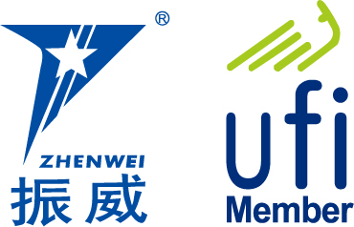

cippe 2014 Profile
China International Petroleum & Petrochemical Technology and Equipment Exhibition (cippe), is a regular gathering in petroleum and petrochemical industry. With a magnificent exhibition over 90,000 sqm, cippe Beijing has successfully attracted 1,600 exhibitors from 65 nations and regions, 15 international pavilions and 60,000 professional visitors. cippe has become the largest petroleum exhibition in the world.
cippe 2013 welcomes an attendance of 12 national pavilions, including USA, Germany, UK, French, Canadian, Danish, Italian, Russian etc. In addition, the well-known global enterprises such as Rosneft, GE, Baker Hughes, National Oil Varco, Schlumberger, Cameron, Schneider, Honeywell, API, Caterpillar, Cummins, MTU, Tyco and Hempel etc all participate in the event.
cippe2013 has received great support from the domestic oil giants such as CNPC Pavilion, Sinopec Oil Engineering Machinery Company, CNOOC, CSSC, CSIC, CIMC RAFFLES, RG Petro-machinery Group, HONGHUA, YANTAI JEREH, KERUI, JUNMA, Shengli Oilfield Highland Petroleum, SHENKAI, HUABEI RONGSHENG, Tianjin LILIN and etc.
Over 100 professional purchasing groups joined in cippe 2013. The professional visiting groups include CNPC, SINOPEC, CNOOC, Overseas Project Department of CNODC, China Petrolum Pipeline Bureau, Sinotrans-CSC, COSCO, Fuel oils Research of the General Logistics Department of PLA, Fuel oils Research Institute of the Air Force, Saudi Aramco, Shell, Total, Gazprom, Rosneft, ConocoPhillips Statoil, Petrobras etc, and professional buyers from Sudan, Ukraine and so on.
The 14th China International Petroleum & Petrochemical Technology and Equipment Exhibition (cippe Zhenwei International Petroleum Exhibition) will be held on March 19-21, 2014 in New China International Exhibition Center. You are cordially welcomed to join us!
Exhibit Profile
■ Oil & gas exploration, exploit, and production equipment
■ Petroleum & petrochemical equipment and manufacturing
■ Technology and equipment for geophysical exploration, well logging and drilling ( for onshore and offshore ).
■ Examination & repair, maintenance, and management of petroleum & petrochemical equipments
■ Technology and equipment for oil and gas pipeline engineering
■ Technology and equipment for scientific research and laboratory in petroleum & petrochemical industry
■ Driving Machinery including generation set
■ Technological process and equipment for oil refining.
■ PCL & DCS Control System, On-site Bus Technical Equipment
■ Industrial automation plant and instrumentation
■ Oil & gas ground technical equipment
■ Technologies and equipment for safety, environmental protection, and energy conservation
■ Petrochemical production and advanced material
■ Electrical & electronic equipment, cable and electric wire
■ Sales system and facilities in petrol & gas station
■ Pipeline, tank car and special vehicles for oil and gas transportation
■ Fluid control equipment- Compressor, Pump, Blower and Valve
■ Fire and alarm equipment, articles for industrial safety and labor protection
■ Industrial explosion-proof products
■ Equipment for industrial rinsing, technology and material for anti-corrosion.
■ Communication, management information system, and e-commerce
■ Technology and equipment for loading & unloading, packaging, storing & transporting

Concurrent Exhibitions:
- The 14th China International Offshore Oil & Gas Exhibition （ciooe）
- The 14th China International Exhibition on Equipment of Pipeline and Oil & Gas Storage and Transportation (CIPE)
- The 14th China International Explosion Protection Electric Technology & Equipment Exhibition
- China Maritime International Marine Technology & Equipment Exhibition
Technical Seminar
During the exhibition, we will hold the topic seminars to assist with exhibitors in holding multi technical communication as well as products launch. Each seminar lasts one hour with CNY 8,000 as the standard expense, and it includes the expenses of event areas and rents of relevant equipment.

Exhibition Rule
- Exhibit space cost: We provide International exhibitors with two participating options.
- Space with Shell Scheme:
Price: standard CNY 30,000 / 9 sqm; Regular size : 3m×3m.
This option includes back & inside walls, carpet, fascia board, one consulting desk, two chairs, two lights and one panel of power points (220V, 5A).
- Raw Space:
Price: CNY 3,200 per sqm (minimum 36 sqm) The exhibitors can appoint their own stand contractor or delegate official contractor to customize their stand design. Carpet is not included.
- Additional Exhibitor Service (not required):
Price: CNY 1,200/person (It includes lunches, beverages, opening banquet, gifts, etc)
- Sponsorship Package of cippe
Banquet Sponsor (Exclusive, CNY250, 000)
The banquet with around 600 people,includes VIPs, exhibitors, summit delegates and leaders of visiting and purchasing parties etc. You would get the multiple market promotion paybacks through the banquet.
Gift Sponsor (CNY200, 000)
Distribute to VIP guests. It is the way to show the strength of enterprises and to build strong brands and strengthen its market position.
Exhibition Catalogue Ad.: It will help you to find target consumers. Not only be distributed to professional visitors during the exhibition, but also be distributed through various channels after the exhibition.
Front Cover | CNY 25,000 | Inside Back Cover | CNY 15,000
Back Cover | CNY 20,000 | Head Page | CNY 18,000
Inside Front Cover | CNY 18,000 | Colored Inside Page | CNY 8,000
Size of Catalogue: 130 mm (w) × 210 mm (h)
Show Daily: It will be produced and printed each day during the event, allowing participants to stay up to speed on the latest industry news from the show even around the globe. Whether you want to alert participants to your booth number, build brand awareness, strengthen your company profile, buy or sell goods and services, or recruit professionals.
Form of Ad. | Publishing Price
Full page | US$7,300 per insertion
Half page | US$3,650 per insertion
US Junior | US$2,628 per insertion
Module 15 | US$1,460 per insertion
Lots of Sponsorship Opportunities are available, such as Visitor Guide Sponsor, Onsite Banner Sponsor, etc. For more information please contact the cippe organizing committee.

Organizer: Beijing Zhenwei Exhibition Co., Ltd.

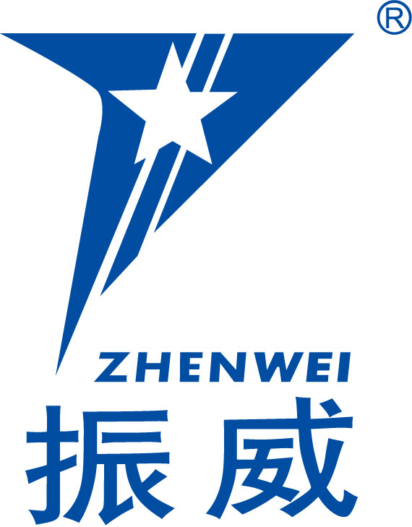
Add: 801, Building E, Kaixuancheng,170, Beiyuan Road, Chaoyang District, Beijing 100101, China
Tel: +86-10-5823 6578 Fax: +86-10-5823 6567
Mob: +86-13501316011
Http: // www.cippe.com.cn
E-mail: wenqi@zhenweiexpo.com
Contact：Mike Wen

The 14^{h} China International Petroleum & Petrochemical
Technology and Equipment Exhibition
March 19-21, 2014 New China International Exhibition Center, Beijing

Please fill out the form below and then send it back to the organizer via fax or email.
Company Name:
Address: Country: Postal/Zip code:
Contact Person (Mr. /Ms): Position:
Tel: Fax:
Website: E-mail:
Main products/exhibits (English):
Exhibition Mode and Cost
1. Space with shell scheme: sqm (standard CNY30, 000 / 9sqm)
Preferred booth numbers: Fee:
Raw space: sqm (minimum 36 sqm CNY3, 200 / sqm)
Preferred booth numbers: Fee:
2. Advertisement in the Expo Catalogue:
□Front Cover CNY25,000 □Inside Front Cover CNY 18,000 □Head Page CNY18,000 □Back Cover CNY20,000 □Inside Back Cover CNY15,000 □ Colored Inside Page CNY8,000
3. Show Daily:
□Full page US$8,065 per insertion □Half page US$4,032 per insertion
□A4 Junior US$4,515 per insertion □A4 Full color US$5,160 per insertion
4. Special Recommended Advertisements:
□Visitor Ticket CNY50, 000/50,000pieces □Hanging Banner CNY 50,000/single-side
5. Technical Seminar: Session(s) (CNY8000/session), Fee:
6. Additional Exhibitor Service (CNY1, 200/person, including lunches, beverages, entrance to opening banquet, gifts, etc.): Person(s), Fee:
★Total fee for attendance: Payment Date:
★Special Attention: Please remit the total participation fee to the account appointed by the organizer within 10 business days upon receipt the confirmation letter, and then fax or email the remittance slip/copy to the organizer’s office in time. Booking received without this deposit will not be confirmed.

Beijing Zhenwei Exhibition Co.,Ltd. Applicant:
Tianjin Zhenwei Exhibition Co., Ltd. Tel:
Tel: +86 10 5823 6578 Fax:
Fax: +86 10 5823 6567 E-mail:
E-mail: wenqi@zhenweiexpo.com Contact
Contact: Mike Wen

